Casey Gray
ITEC 4365
March 4, 2025
Assignment 4

- Start an application.
$ python manage.py startapp lists
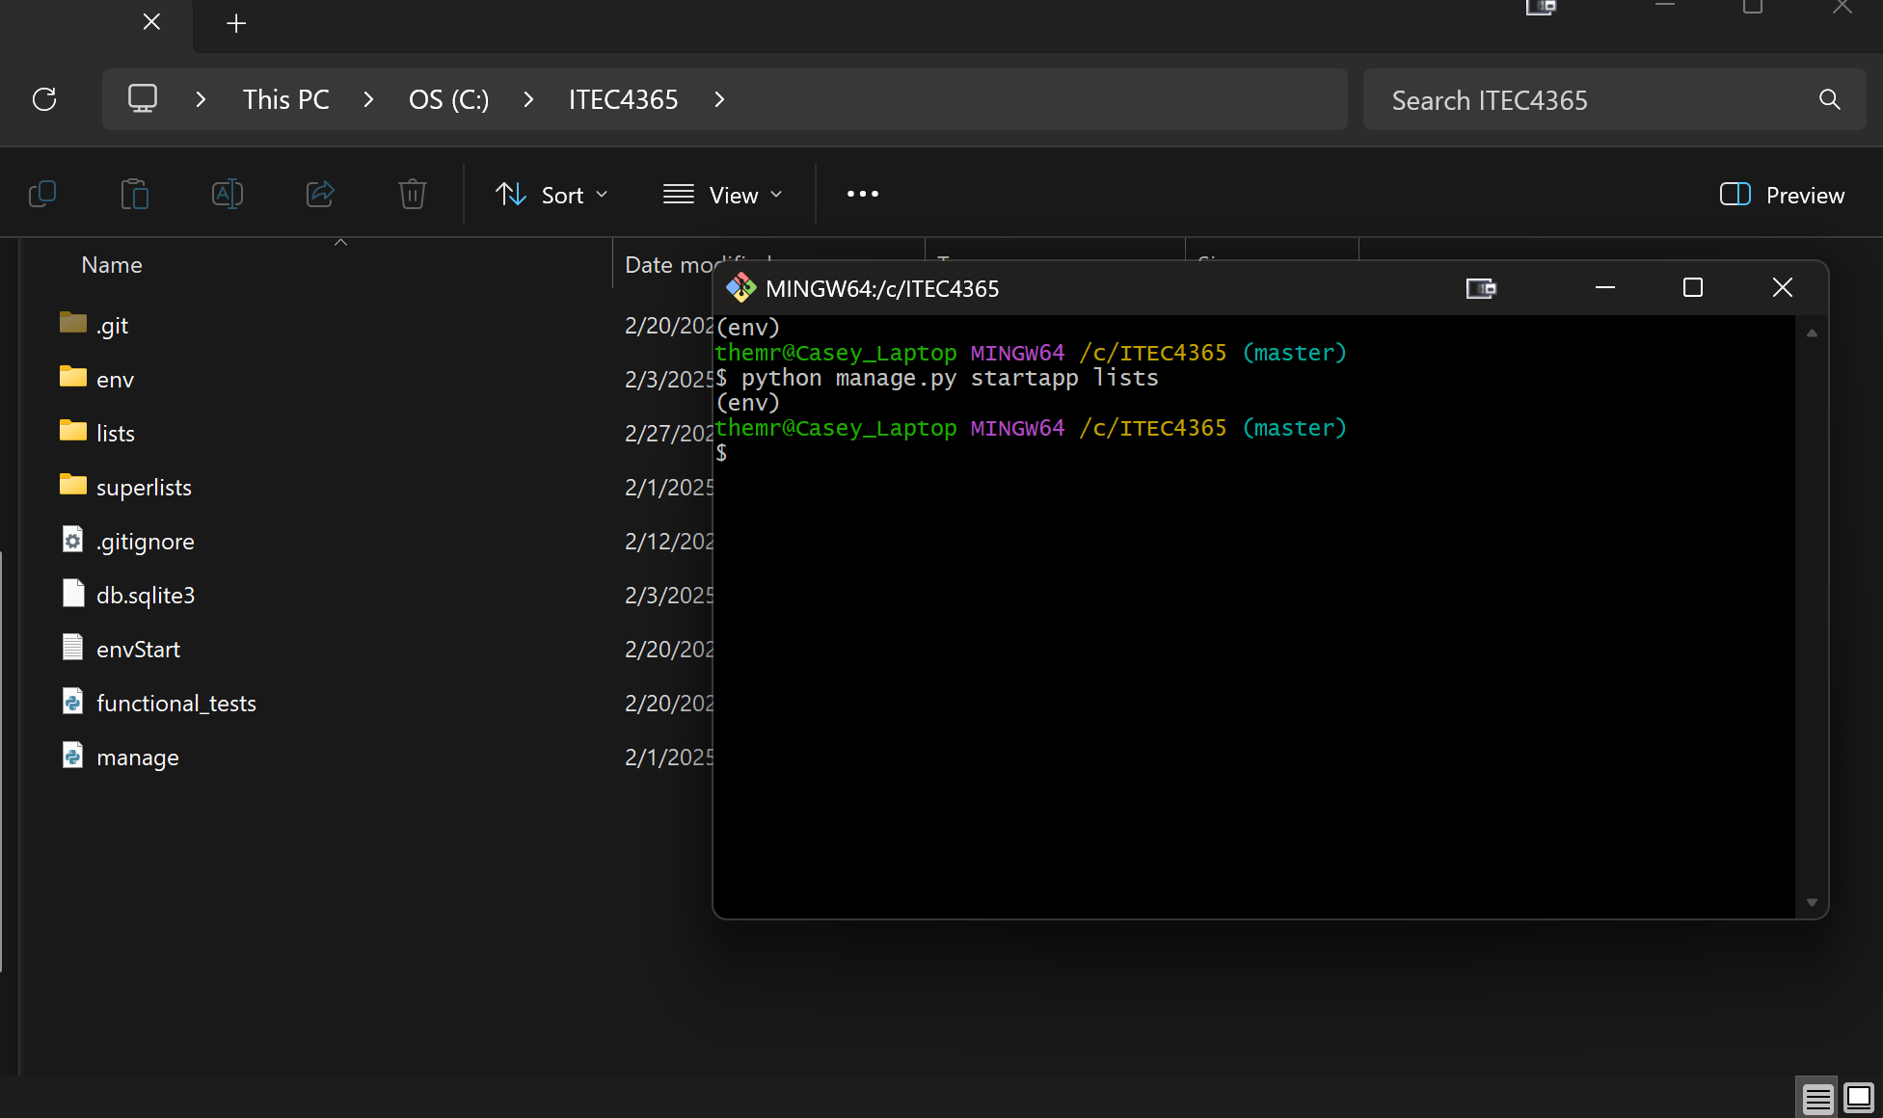

- Unit testing in Django (page 23~24)
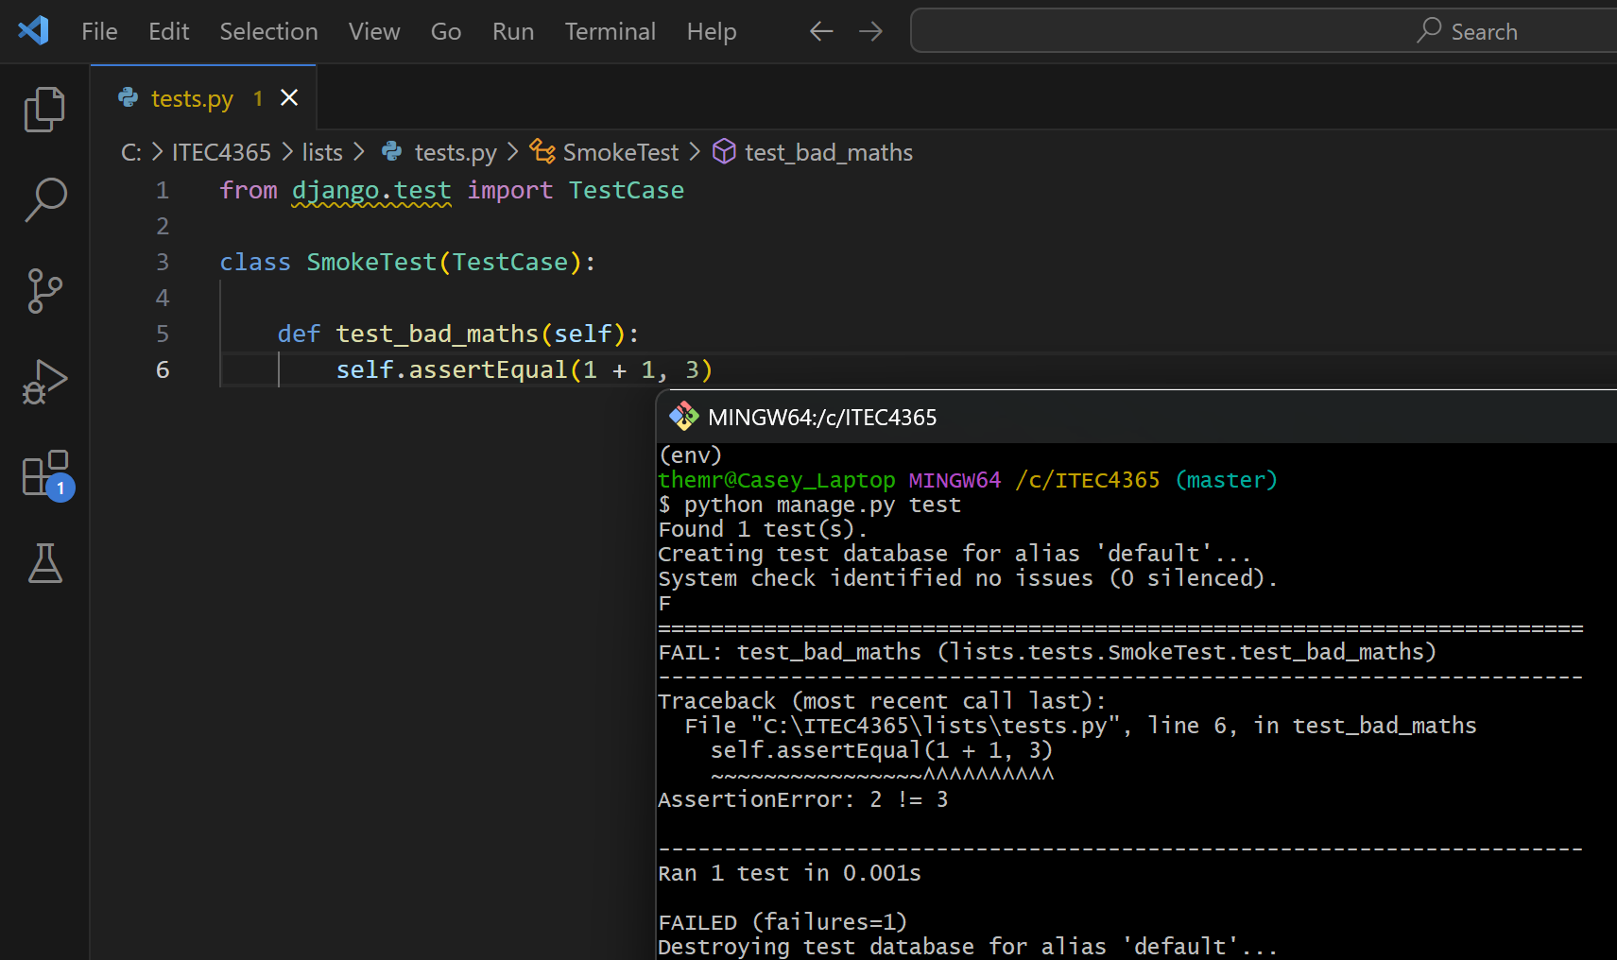

- Run and test new code
- New code & testing code

- git commands (page 24)
- git status
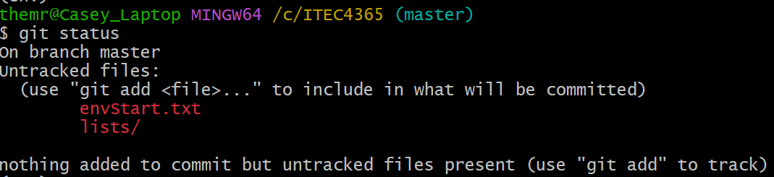
- git add lists & git diff --staged
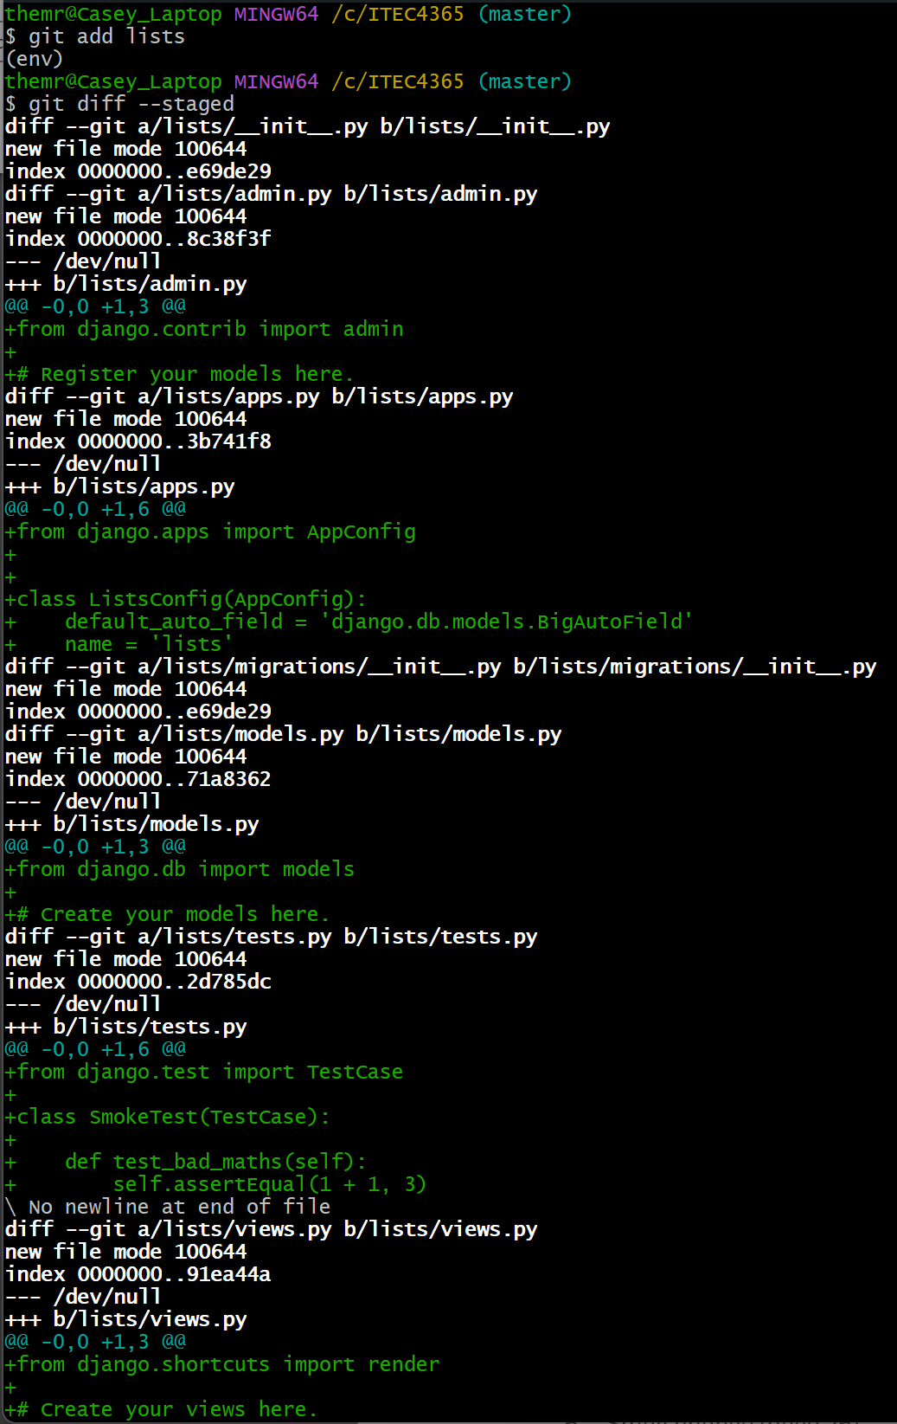
- Committing to git
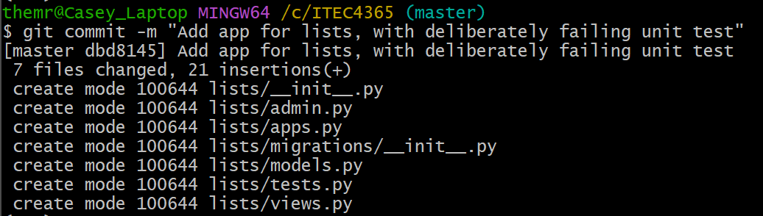

- Django's MVC, URLs, and View Functions (page 25)
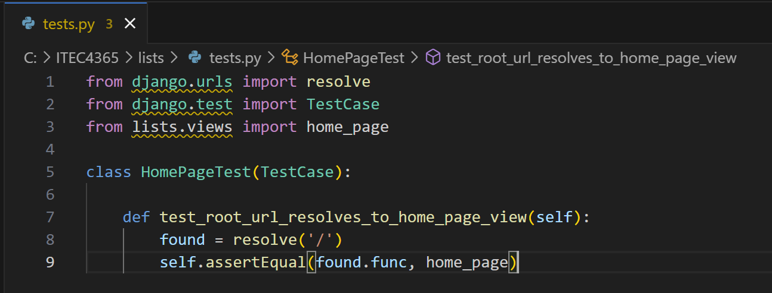
- Small change (page 26)
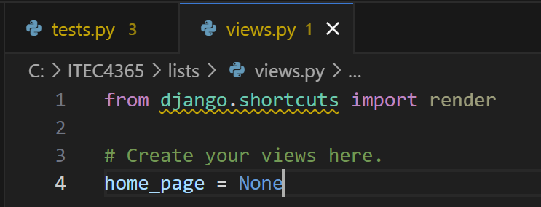
- Run your test again (page 29)
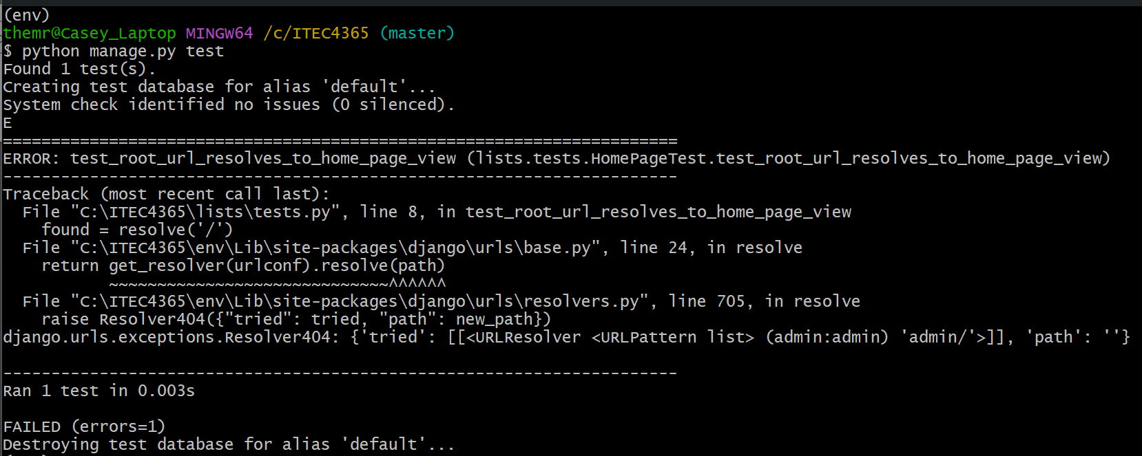
- Unit test the view (page 30)
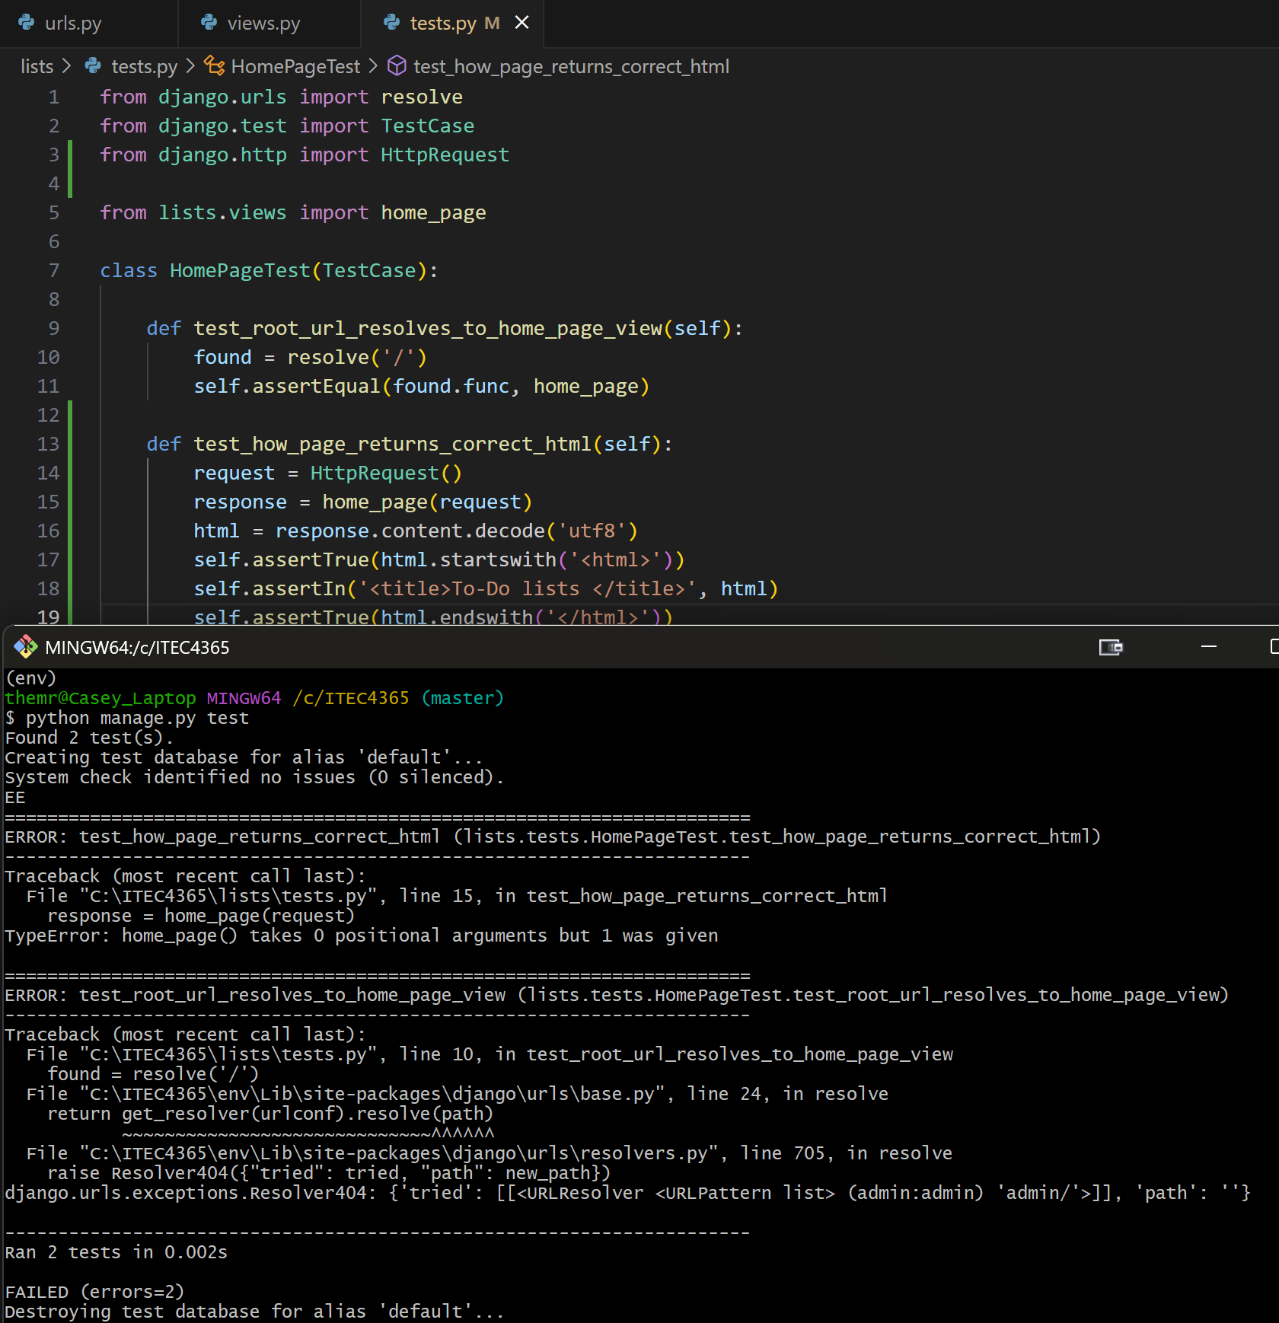

- Unit Test Code Cycle (page 32)
- First change
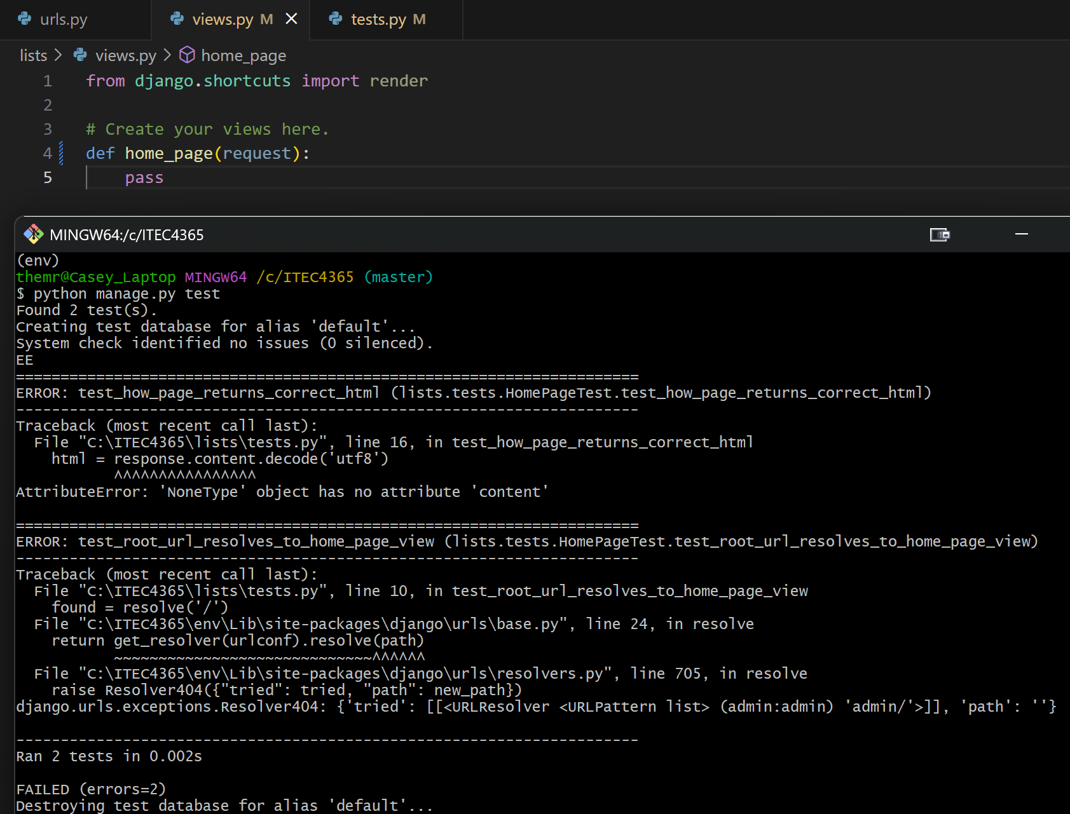

- Second change
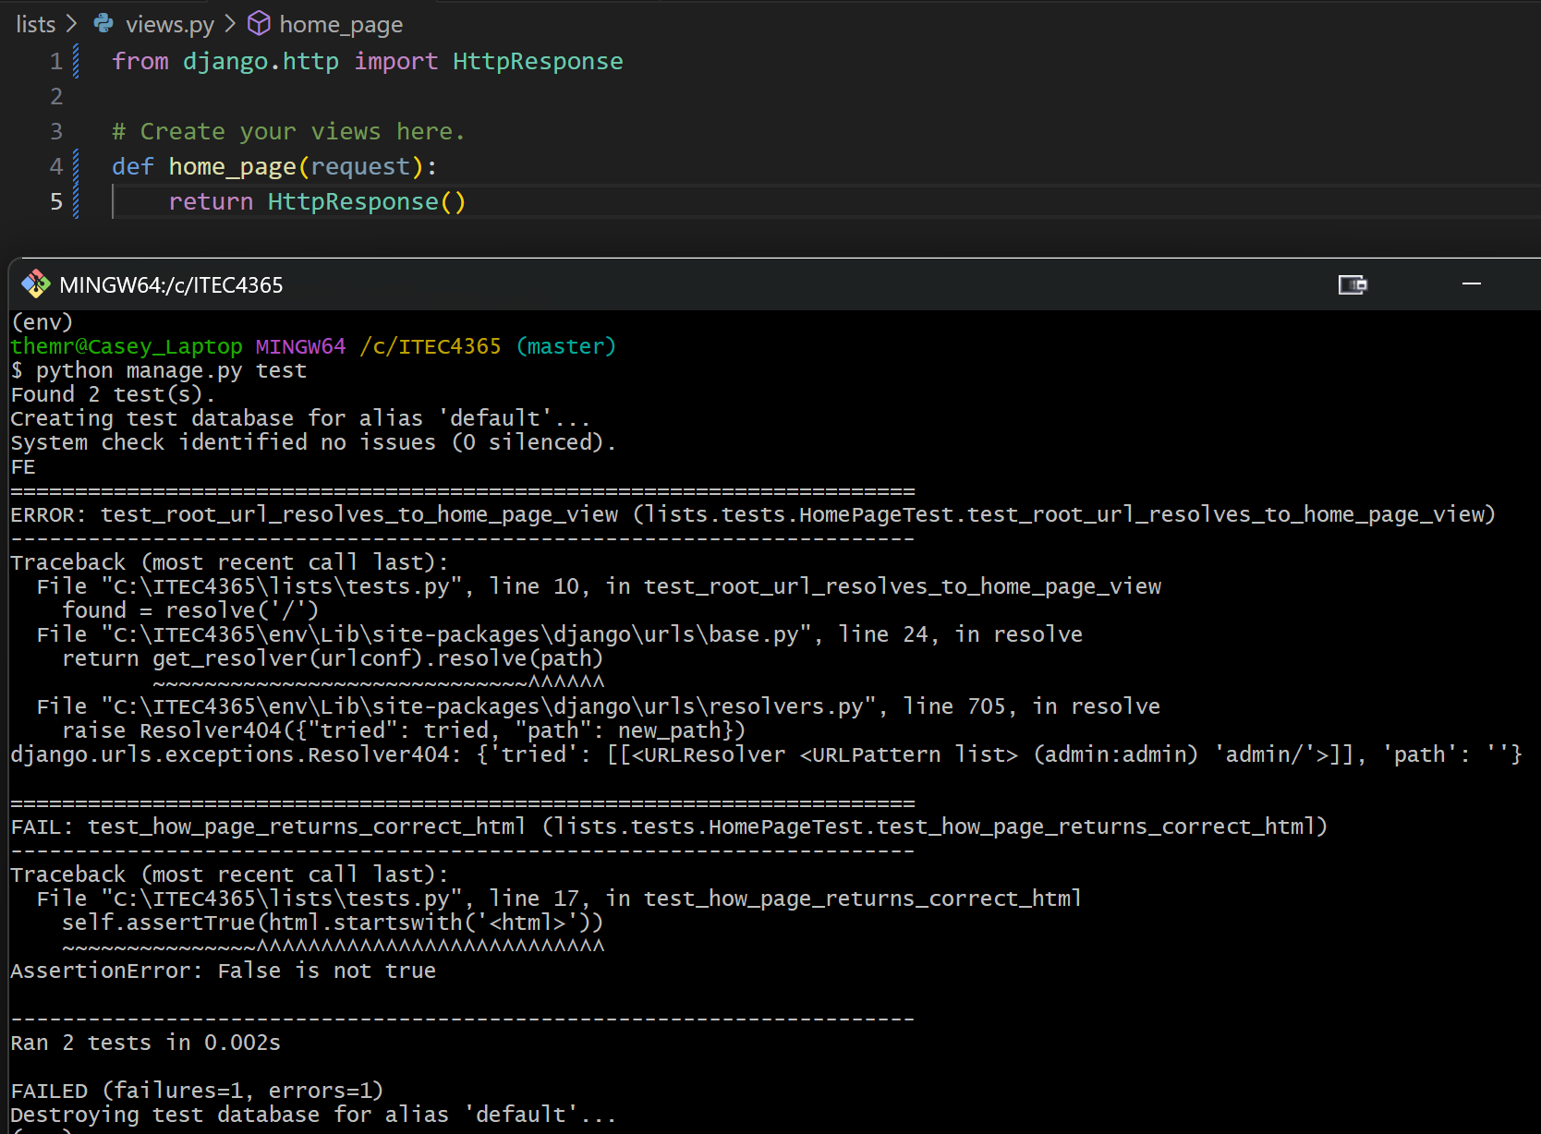

- Third change
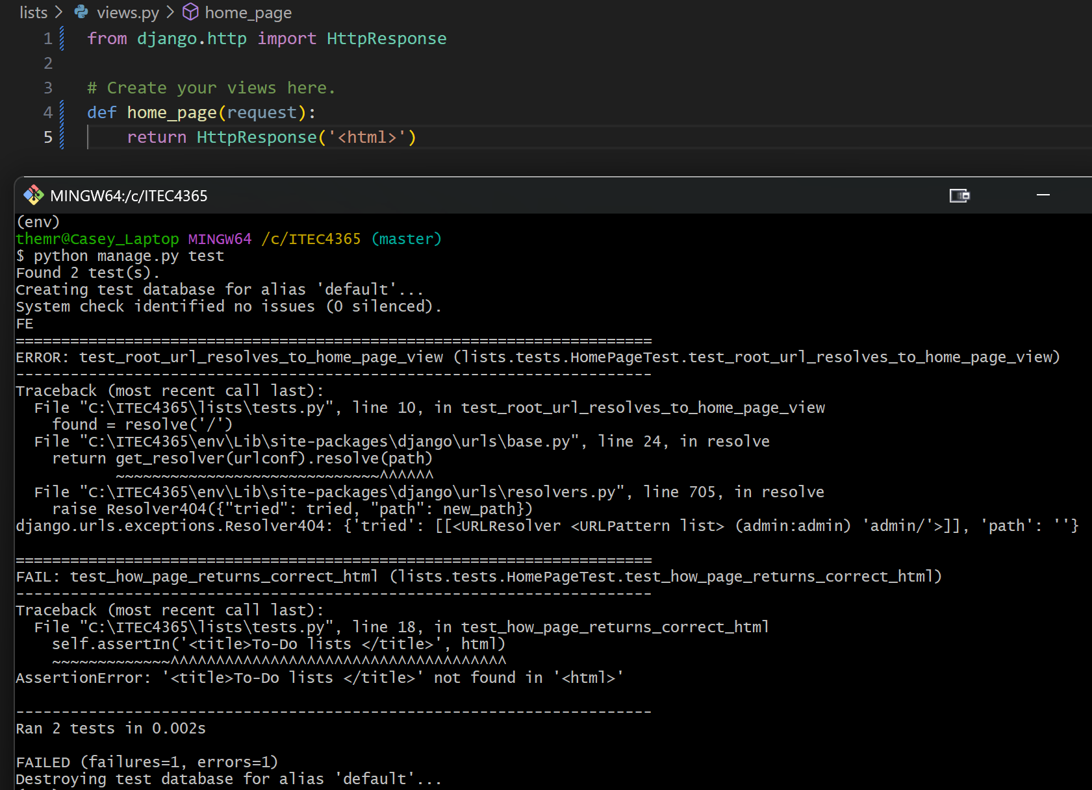

- Fourth change
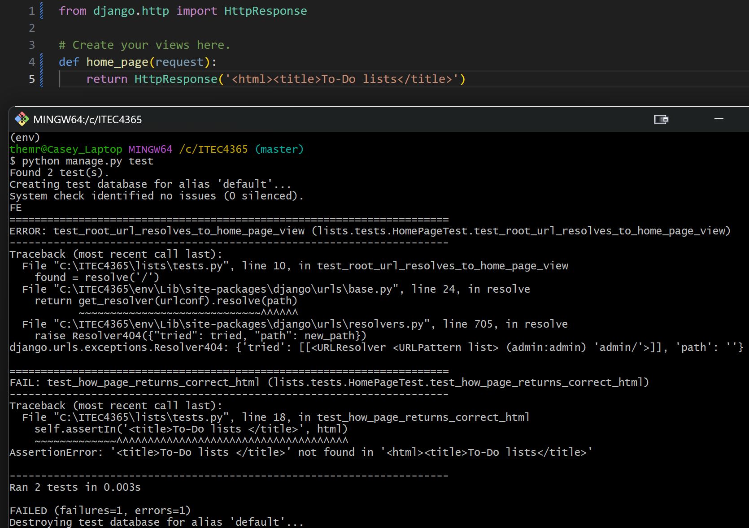

- Fifth change, showing the assertion error is gone
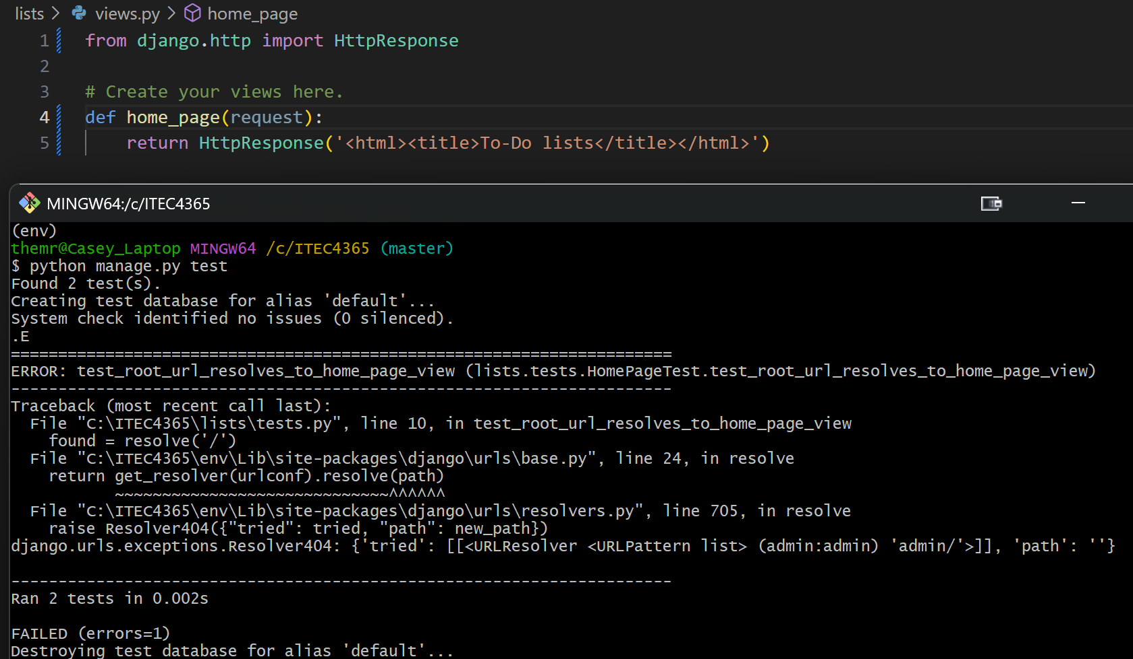

- Sixth change, showing no more errors (changed url.py, as instructed by the professor)
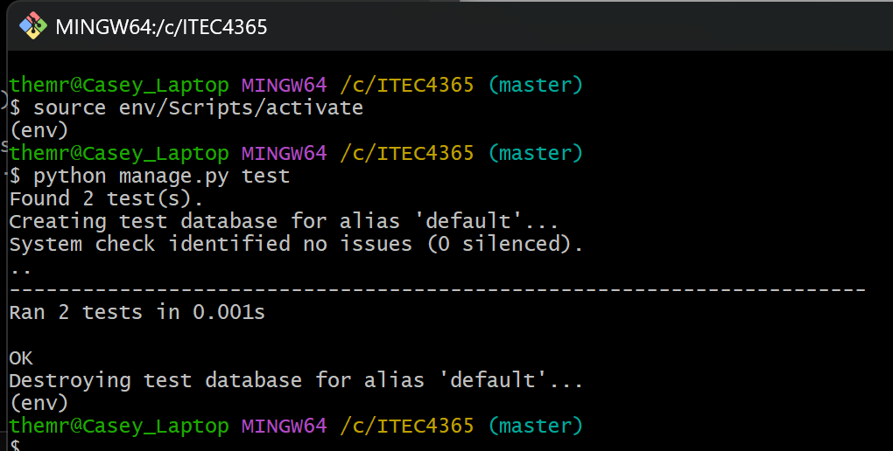

- Showing that functional_tests.py runs correctly according to the text
